Cannabis
The County has developed ordinances for zoning and registering cannabis businesses. Including the following activities; cannabis cultivation, manufacture of cannabis-derived products, sale of cannabis derived products and organizing cannabis-related events. Tools to manage Cannabis Businesses include performance standards, developments standards and allowed uses by zoning districts.

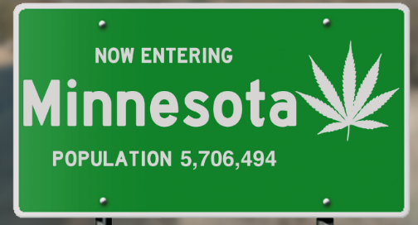
Timeline:
August 1, 2023 | Freeborn County Board of Commissioners direct staff to study and develop a cannabis zoning ordinance.
November 21, 2023 | Cannabis Public Use Ordinance was effective on this date.
July 2, 2024 | Moratorium on the Operation of Cannabis Businesses (Ordinance #2024-00) The moratorium will expire no later than December 31, 2024.
November 4, 2024 | Freeborn County Planning Commission held a public hearing to review proposals and recommended amendments to the zoning ordinance (Ch. 42).
December 2, 2024 | Freeborn County Planning Commission held a second public hearing to review proposals and recommended additional amendments to the zoning ordinance (Ch. 42).
February 18, 2025 | Final approval of cannabis zoning amendments.
March 4th, 2025 | Freeborn County Board of Commissioners held a public hearing and unanimously voted to adopt a cannabis business registration ordinance.

State Role:
The Office of Cannabis Management (OCM) will propagate Minnesota Rules. They will establish a license system and be responsible for licensing cannabis businesses. OCM has developed a Local Government Toolkit. Local government staff can use this workbook for guidance regarding the local government’s role in the application, licensing, and regulatory system for the cannabis industry. The guidance includes a draft model ordinance for local government staff to reference in the development of ordinances. Follow this link to the toolkit: https://mn.gov/ocm/local-governments/localgovs.jsp

