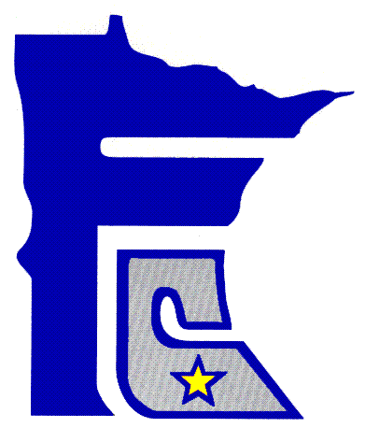
HEATHER A. BAGLEY, COUNTY RECORDER
Government Center – P.O. Box 1147
411 So. Broadway Ave.
Albert Lea, MN 56007
Telephone: 507-377-5130

freeborn
county
minnesota

ESCROW REQUEST/AUTHORIZATION FORM
Account No.
Company Name ___________________________________________________
Address: _________________________________________________________
Contact Person: ___________________________________________________
Telephone # ______________________________________________________
E-mail Address ____________________________________________________

Escrow Funds may be used for:
Document Recording fees
Including wells disclosure fees, certified copies & duplication information
Copies requested within the office
Condition of Register and search fees
Landshark image and monthly fees (if applicable)

On behalf of the above-named company, I authorize the Freeborn County Recorder/ Register of Titles to reduce my escrow balance for the above service charges. I agree that all my employees will present our account number when requesting a debit from our escrow account.
Authorized Signer: ____________________________________ Date:_____________
Title __________________________________________________________________

